Get the conversation going early!

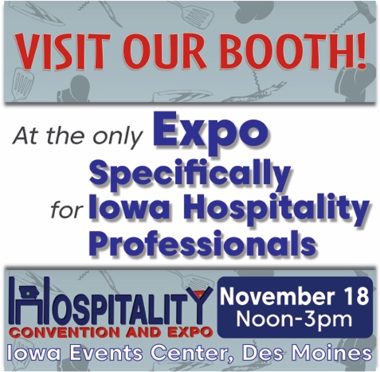
Here are sample posts you can customize and post on your social media platforms. We recommend posting once per and including any relevant pictures to make sure your posts stand out.
Please feel free to use this photo with your post on any social media platform! The photo can be downloaded /saved from this document or from our exhibitor marketing tools page (http://www.iowahospitalityexpo.com/exhibitor-marketing/)

Sample Posts Facebook or Twitter:

We’re exhibiting at @IowaRestaurantAssociation’s Iowa Hospitality Convention & Expo in Des Moines. Register today and join us at the restaurant, foodservice and hospitality event of the year! www.iowahospitalityexpo.com

Looking forward to exhibiting at @IowaRestaurantAssociation’s Iowa Hospitality Convention & Expo in Des Moines. November 18. Come see us where we’ll be <unveiling/showcasing product/service>. www.iowahospitalityexpo.com

Join us at @IowaRestaurantAssociation’s Iowa Hospitality Convention & Expo in Des Moines. We’ll be there <unveiling/showcasing product/service>. Walk the show floor and attend education sessions. Sign up today to see us at www.iowahospitalityexpo.com

Please note: simply copying and pasting these posts will not tag the Iowa Restaurant Association on Facebook. Facebook requires manual tag entry, so you will need to type in @IowaRestaurantAssociation in order to tag the event in your post.

Sample Posts Instagram:

Looking forward to exhibiting at @iowarestaurant’s Iowa Hospitality Convention & Expo in Des Moines November 18! Come see us at our booth where we’ll be <unveiling/showcasing product/service>
